**TIME TABLE MONITORING SYSTEM**

**Home Page**

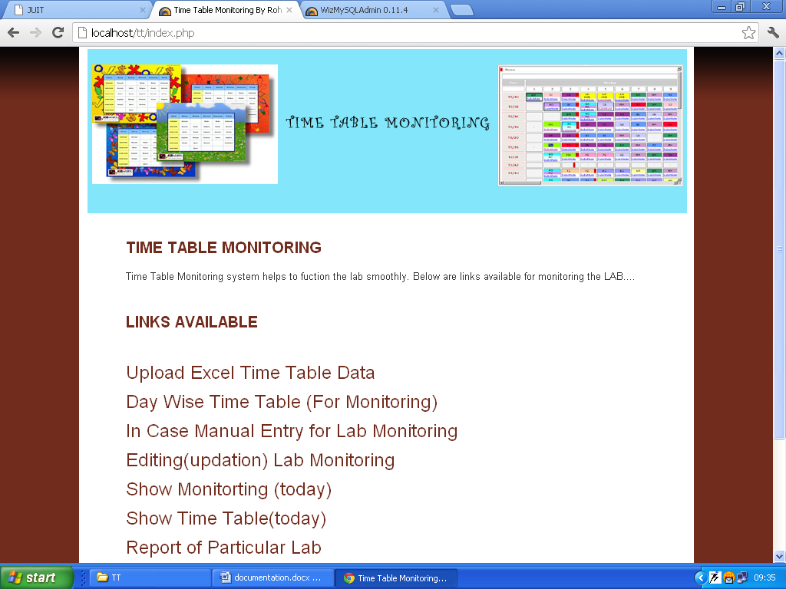

**Available Links**

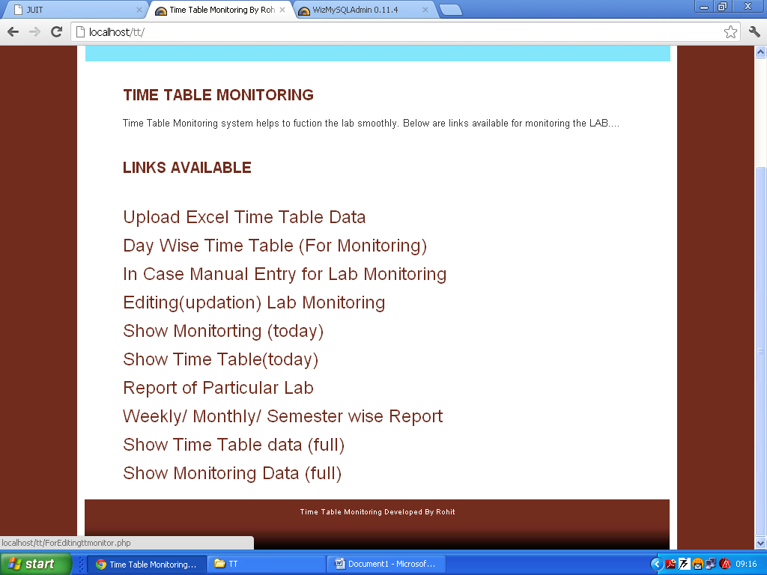

**Select the Excel file (for complete Time Table)**

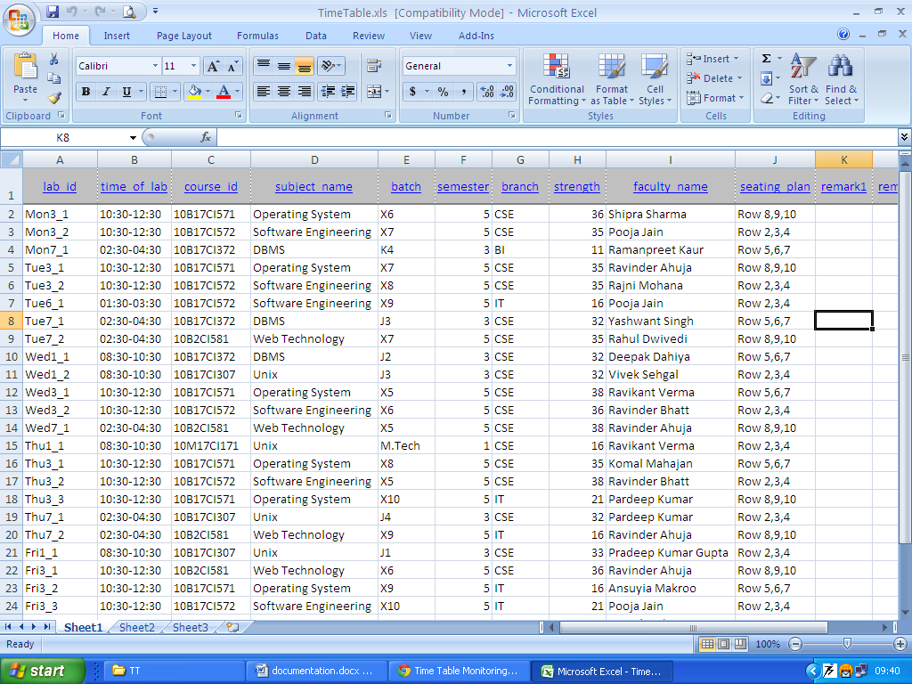

**Select the Excel file to upload in MySQL database**

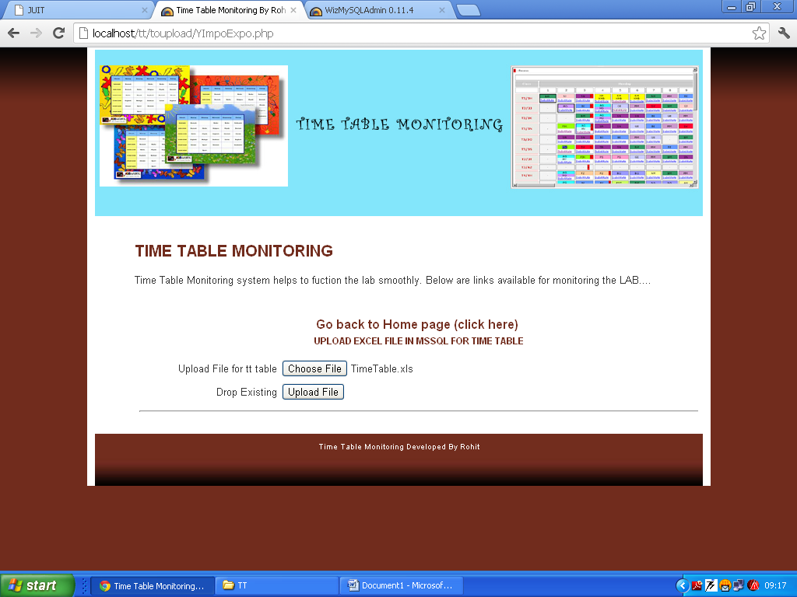

**Excel File Uploaded Successfully (28 Rows inserted in MySQL database)**

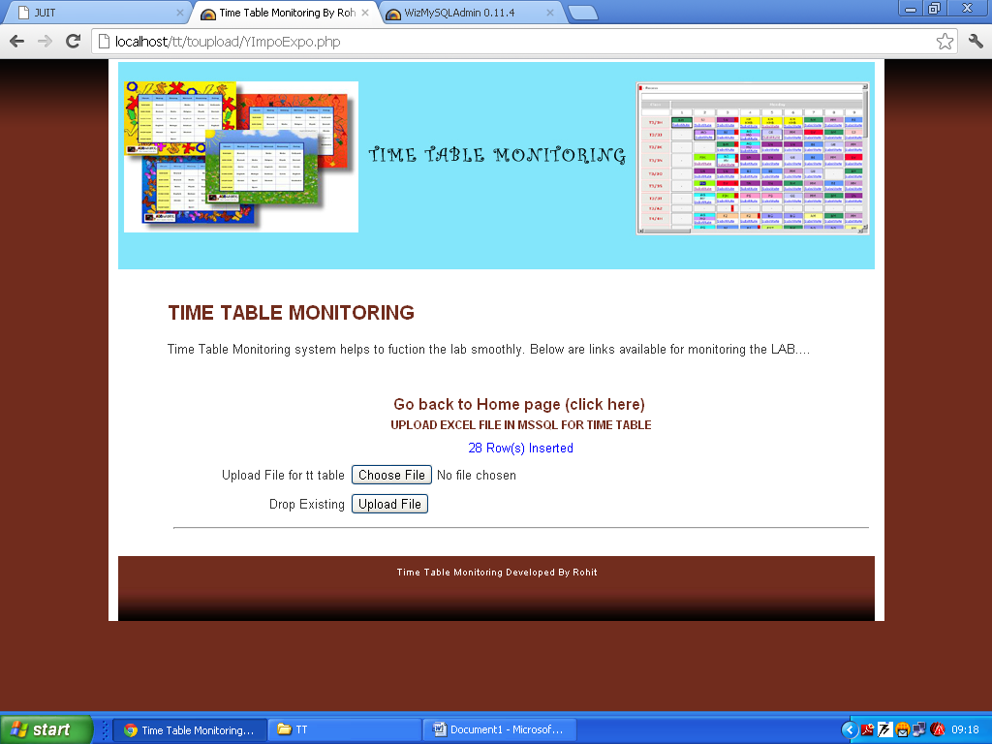

**For Monitoring click Day wise link**

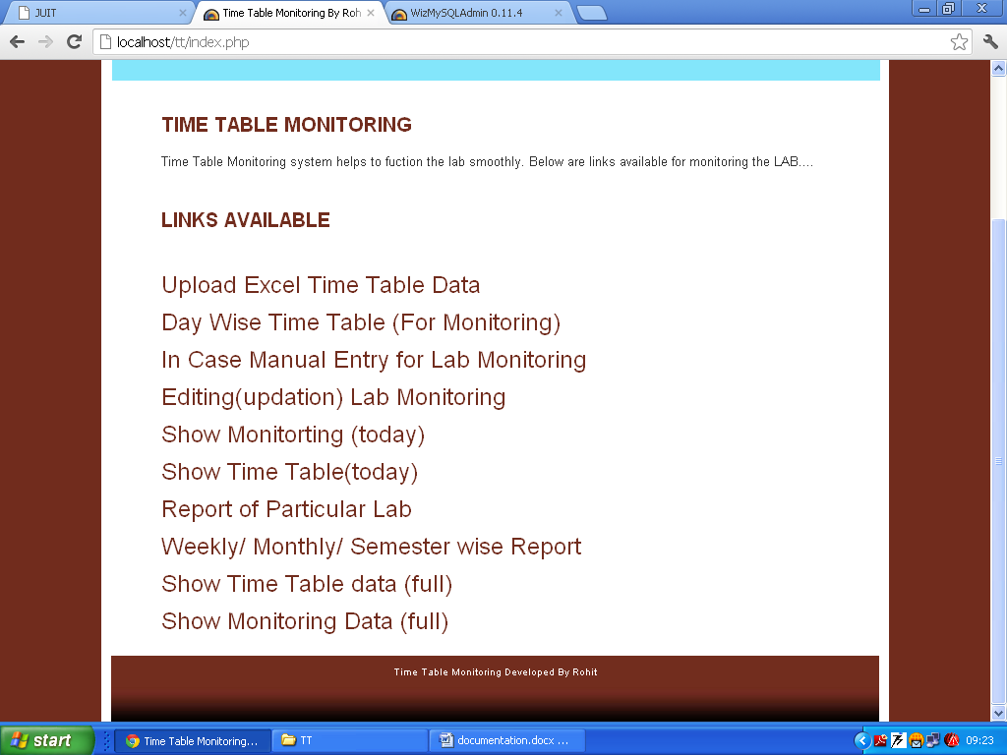

**This page will show the Scheduled labs of the Current Day**

**Click the particular lab to monitor**

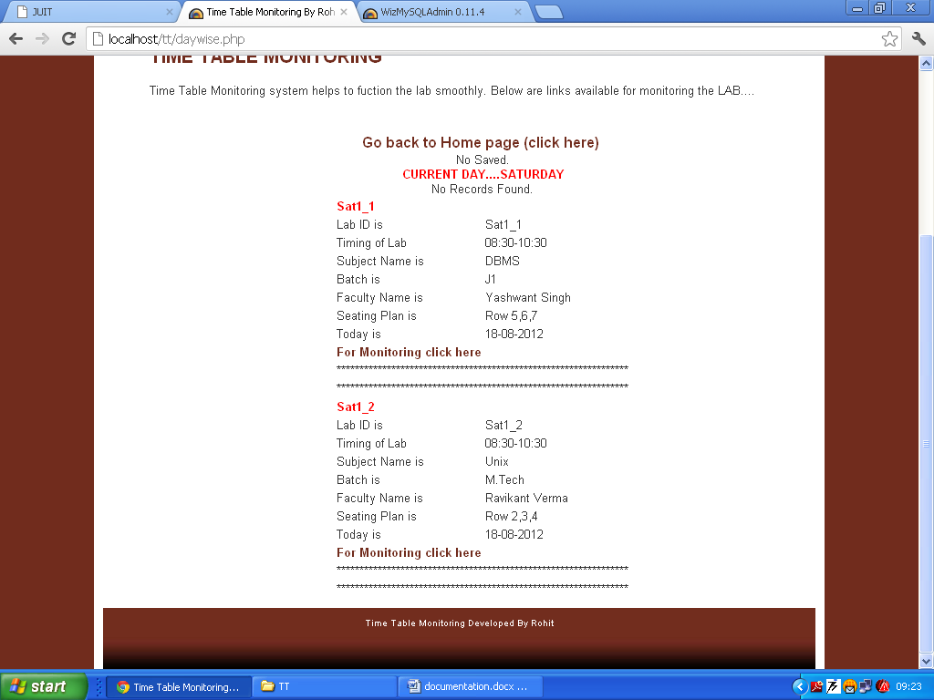

**Enter the Detail of lab**

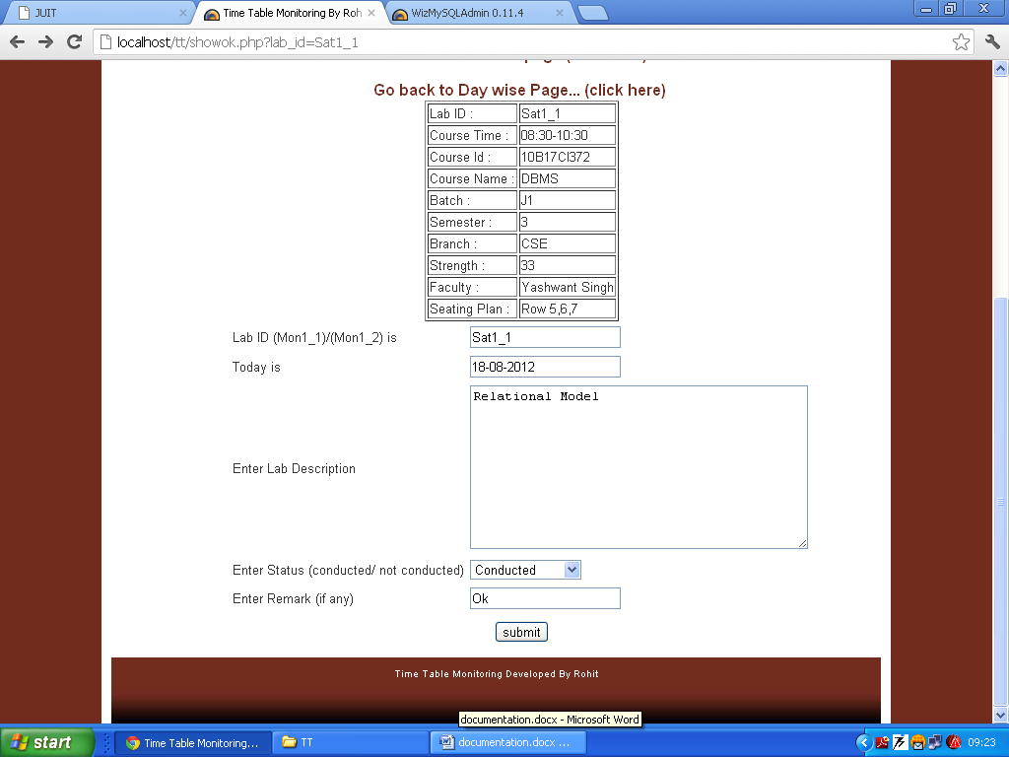

**To Check whether monitored lab is saved or not**



**Lab saved, as shown below**

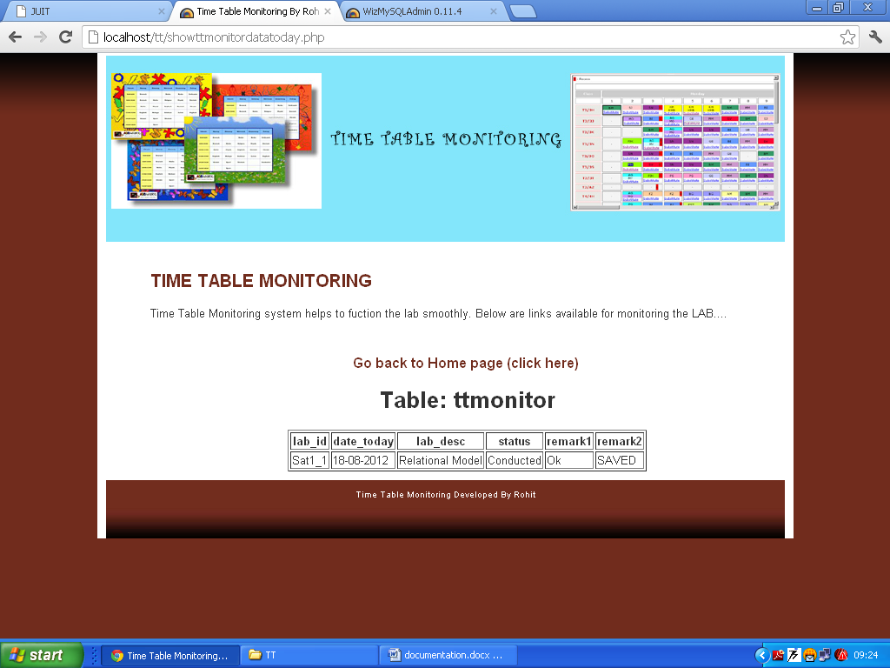

**Again go back to Day wise Time Table**



**Now on Saturday we have left with one scheduled lab, as one is already monitored (Automatically only the left lab is shows, so that user cannot do the mistake)**

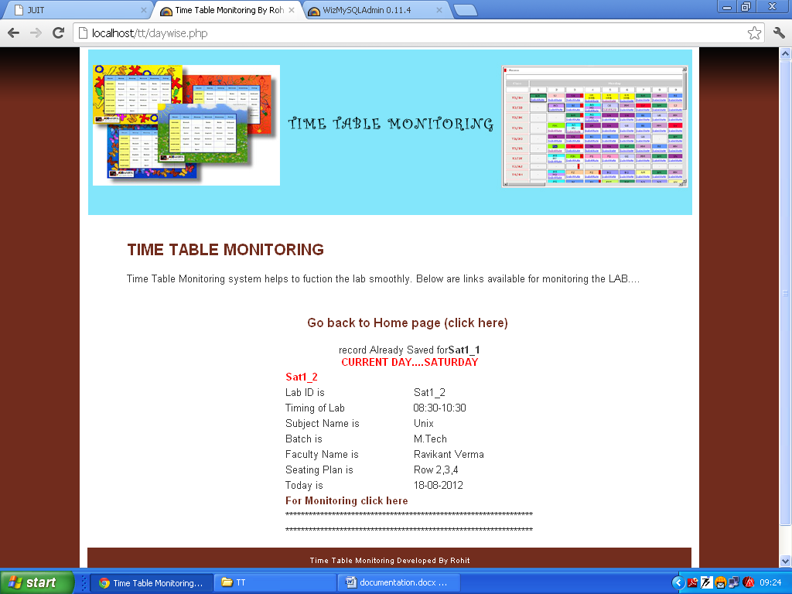

**Enter the Details of lab**

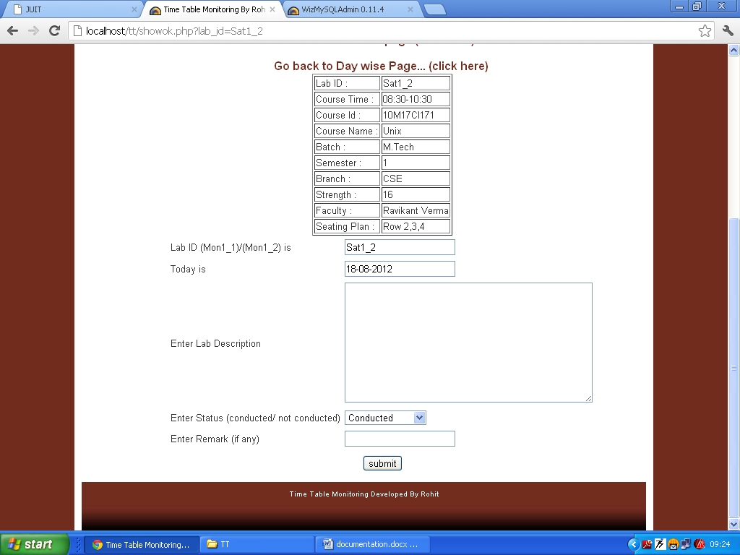

**Now in Day wise, both labs are monitored, so labs record already saved shown**

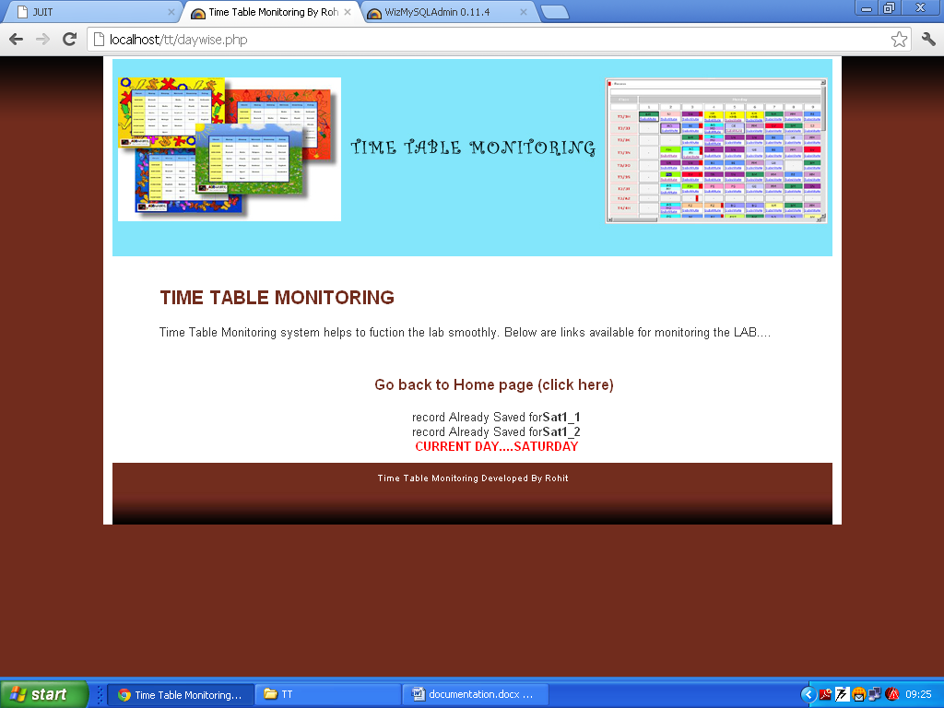

**In case of lab rescheduled or Administration is on leave (Manual Entry option is also available)**

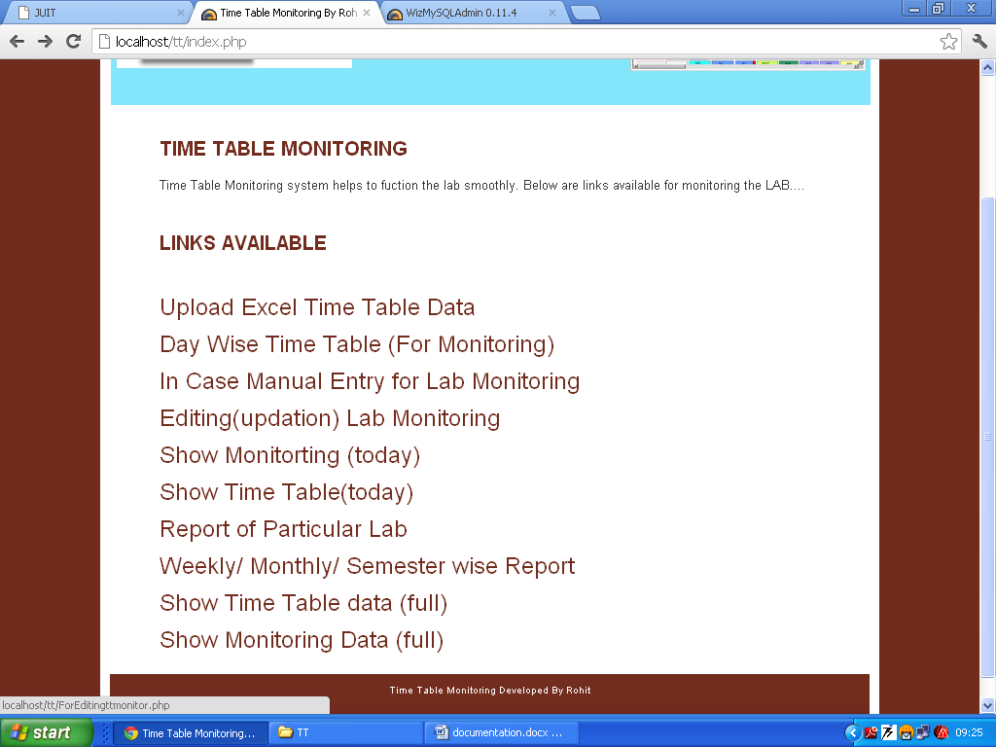

**Enter the Lab ID**

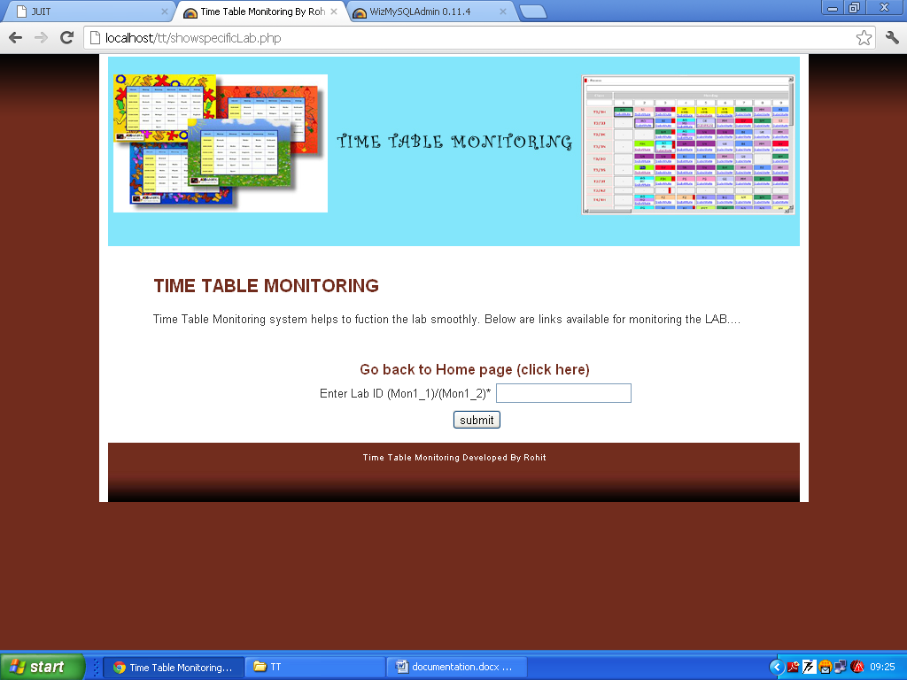

**Do the manual Entry including Date, Description, Status Remark (If any)**

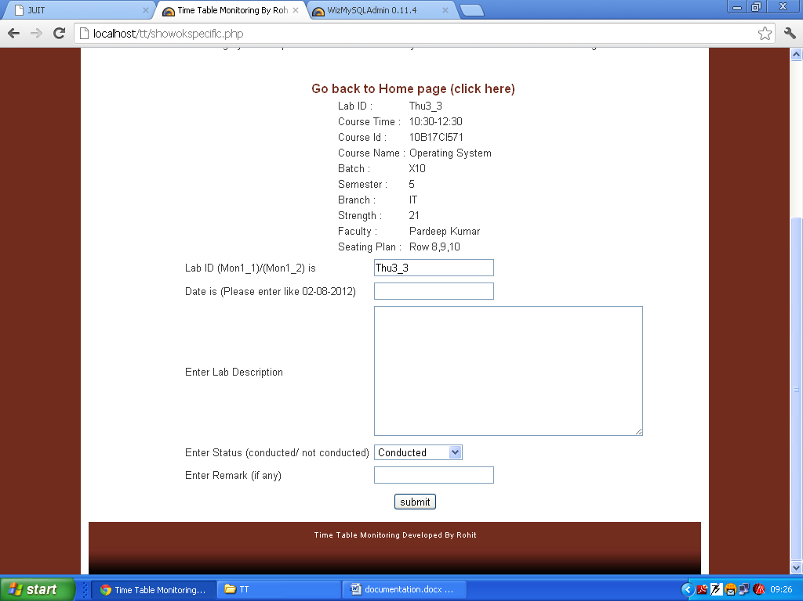

**For Updating the Lab Description**

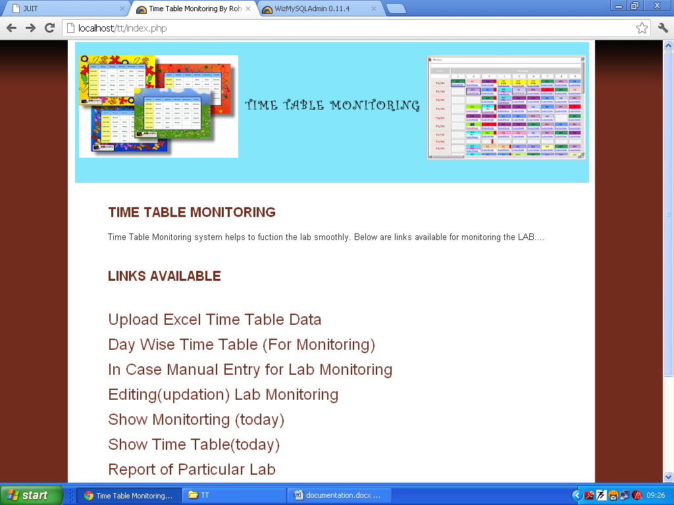

**Enter the lab_id to be updated**

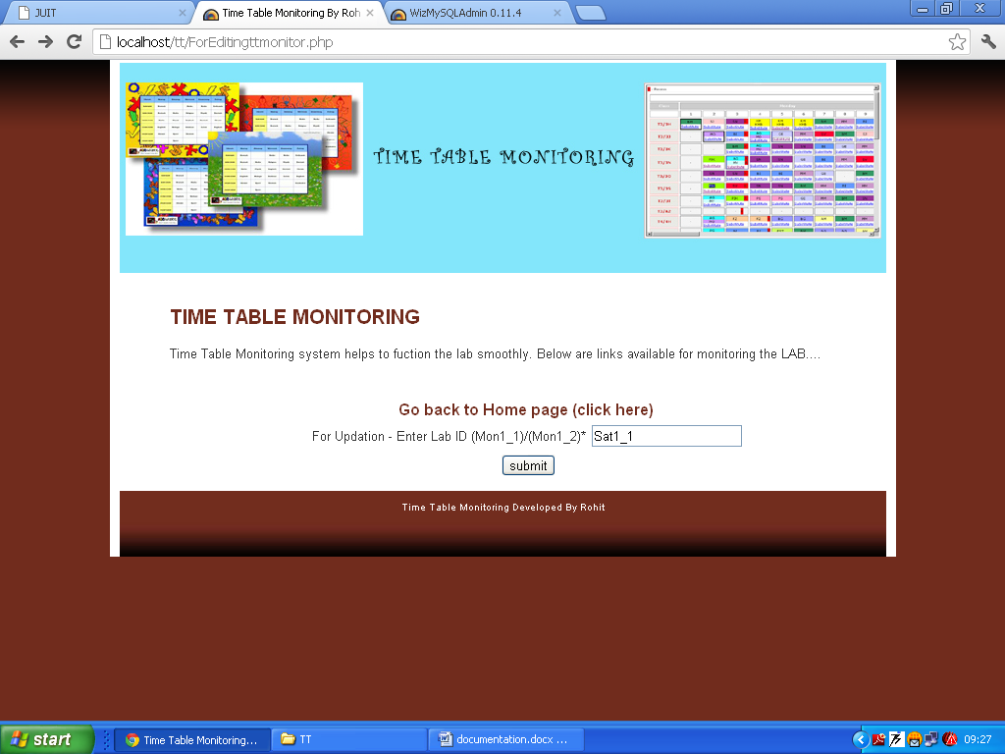

**Data which is already entered in Database, is shown**

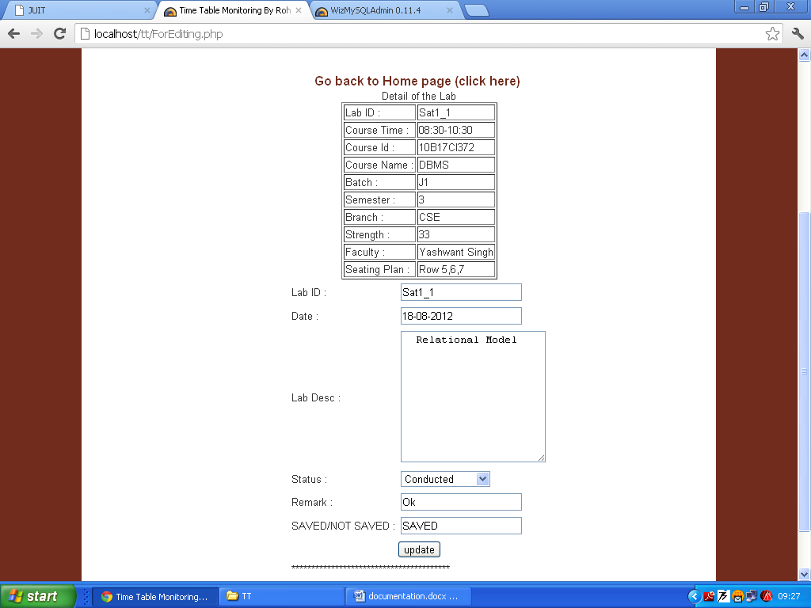

**Do the Changes, click Update button**

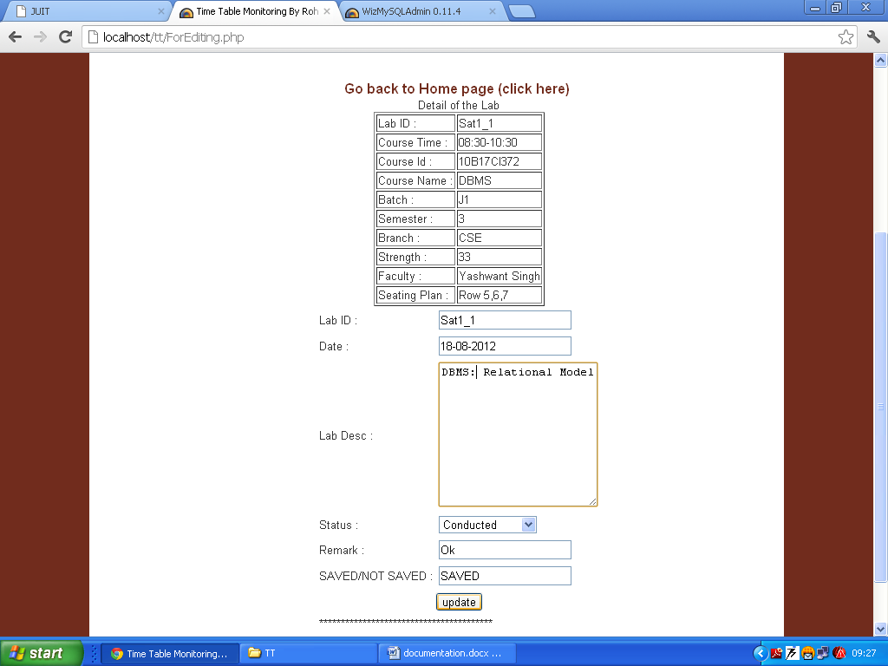

**Using link, show monitoring today. Changes can be seen**

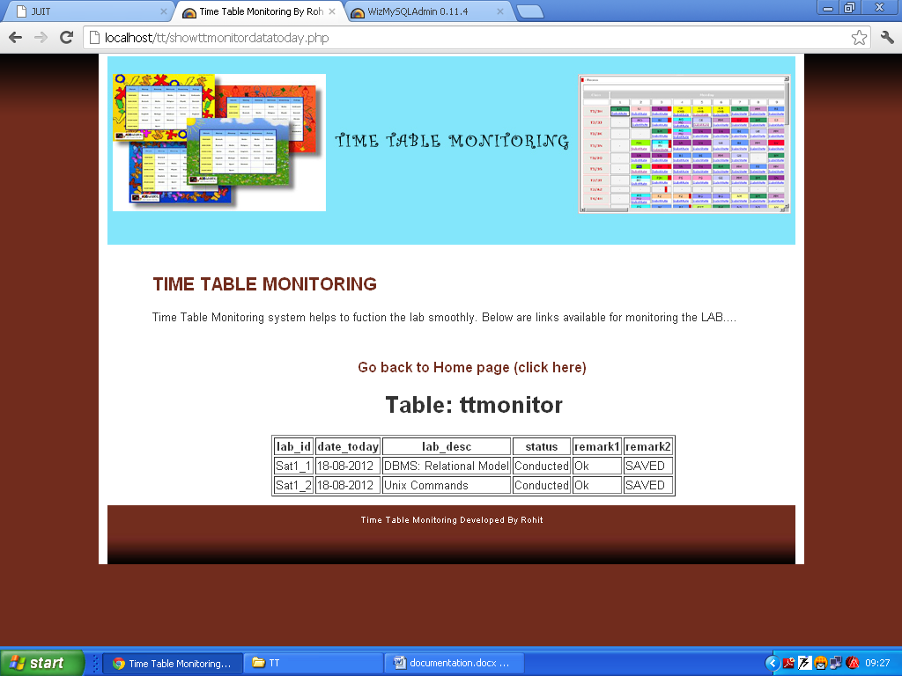

**Show time table of today (say if today is Friday)**

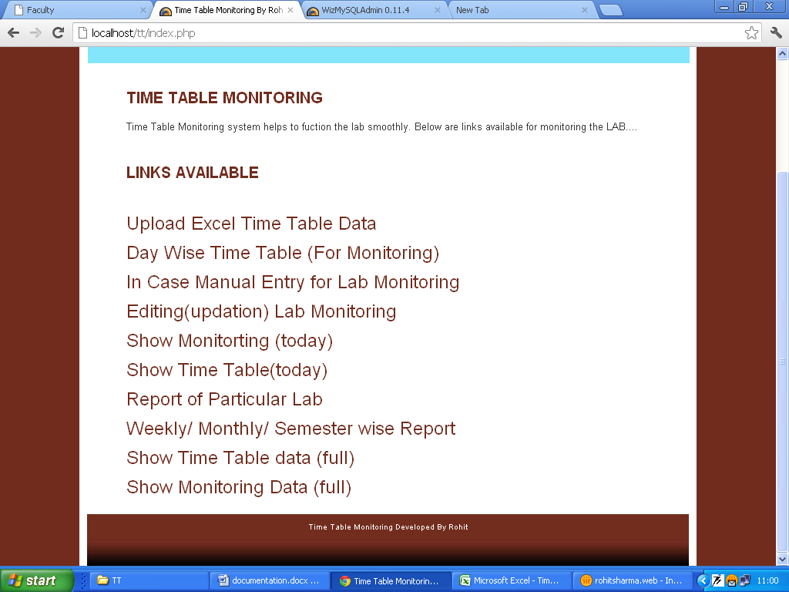

**This option will show Time table of current day**

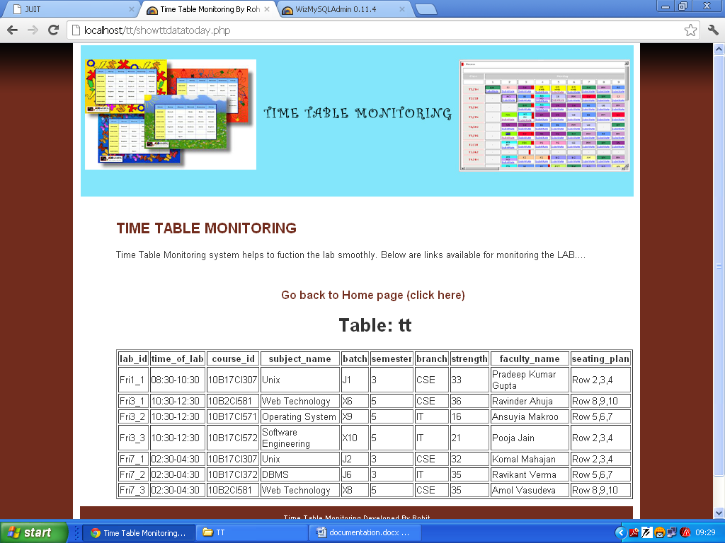

**Show report of particular lab till date**

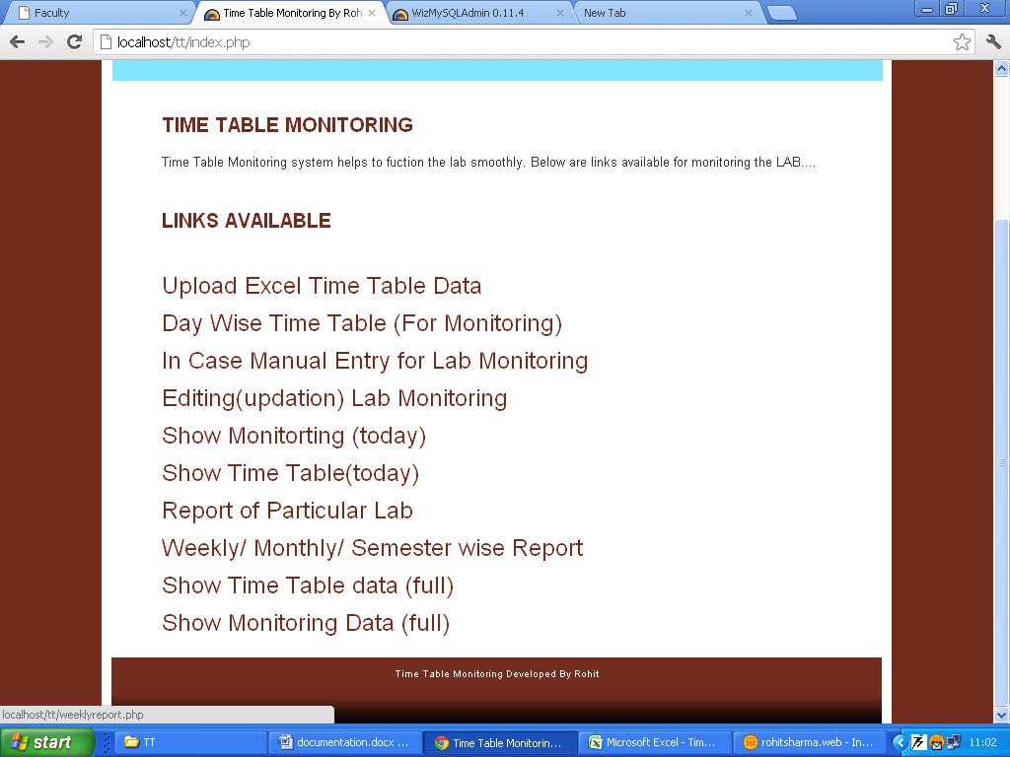

**Enter the lab_id**

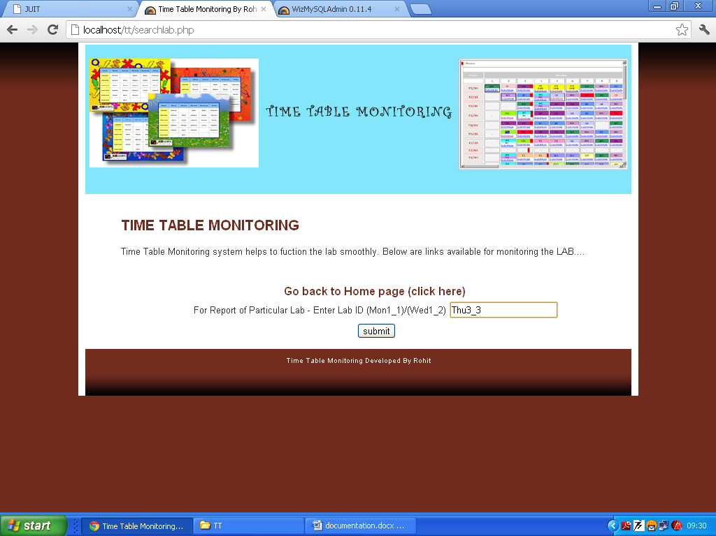

**This will show all records from start to till date of a particular lab**

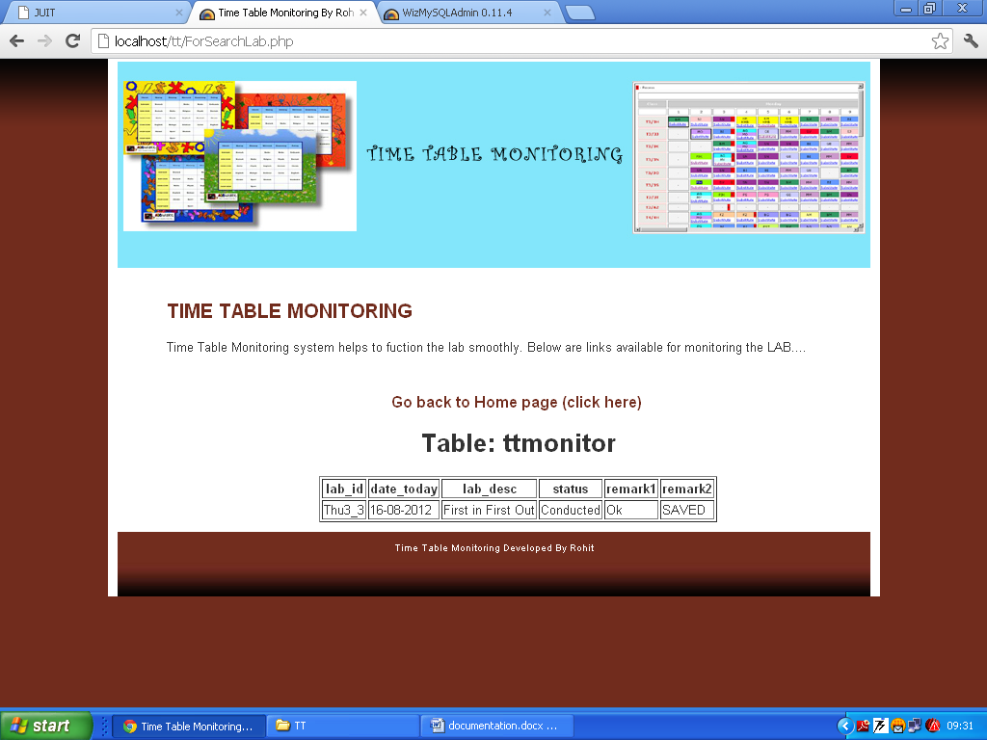

**Weekly/Monthly/Semester wise report**

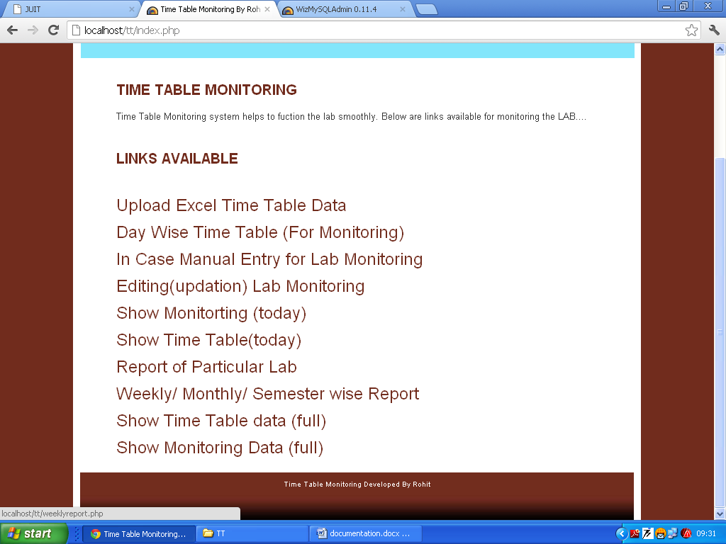

**Enter the date from where to where report required**

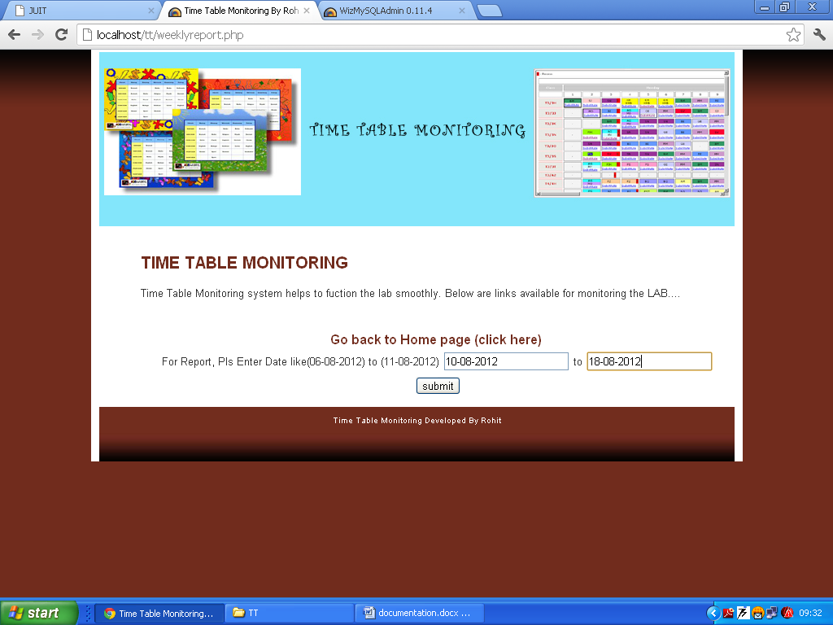

**The required report is generated for a specified period**

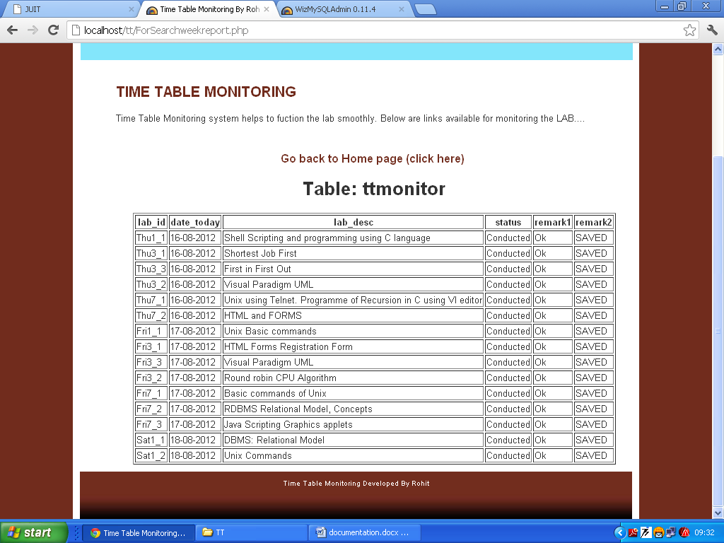

**To show the complete Time Table of the lab**

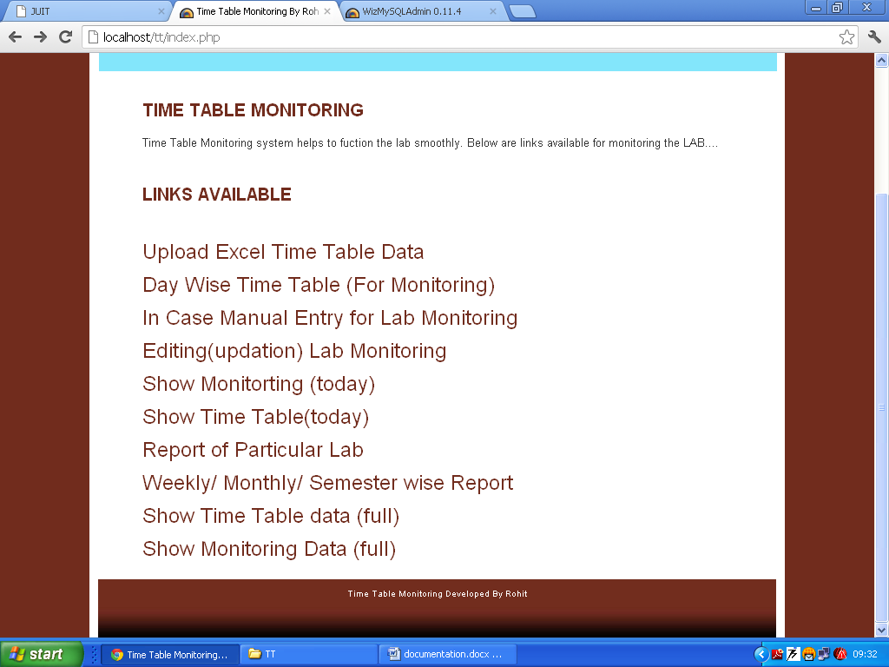

**Complete Time Table of the week is displayed**

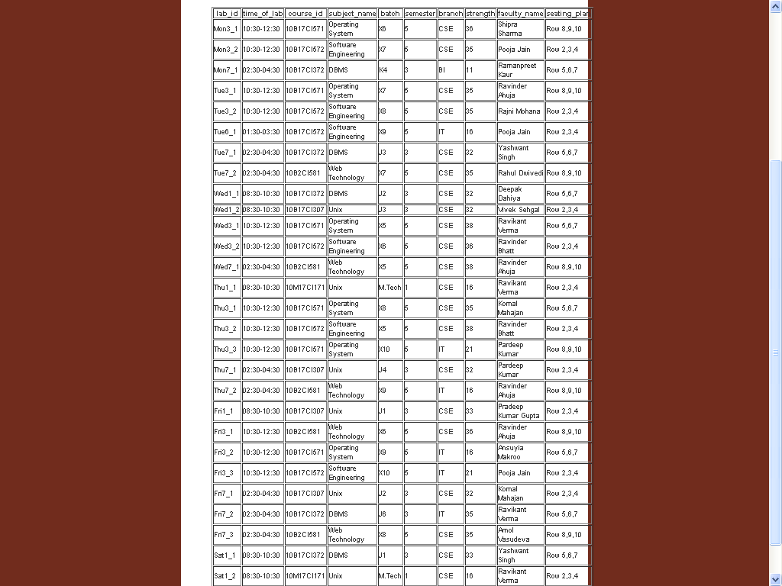

**To show complete monitoring detail, till date.**

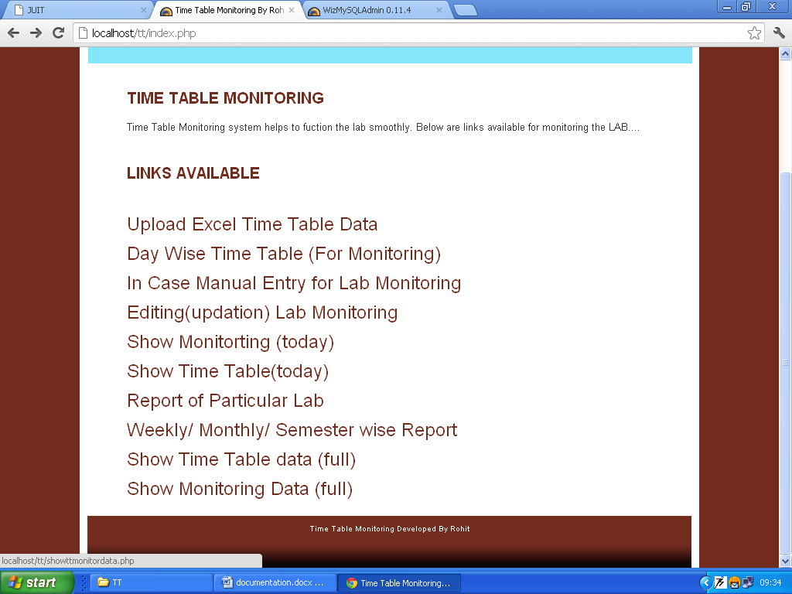

**Complete Monitoring report till date is displayed**

